Familiar and Unfamiliar Navigation Elements Experiment – 04

# Sarvesh R 230701295

1) Sign up page:



A commonly recognized navigation feature, a button, is implemented for the sign-up process. Selecting the "Sign Up" button seamlessly transitions users to the home screen, making it a familiar element.

1. Home Screen



In this section, an unfamiliar navigation approach is introduced know as Infinite Scrolling without visible indicators. This enables continuous browsing without the need for a conventional navigation bar.

1. Book and Manage Option



When users hover over the "Book & Manage" option, a pop-up appears. This represents an unfamiliar method of interaction, as it differs from traditional dropdown menus or direct links.

1. About Screen



1. Clicking the "About Maharaja Club" image activates a pop-up window. This qualifies as an unfamiliar element since the interaction occurs through an image rather than a standard button or link.
2. Footer

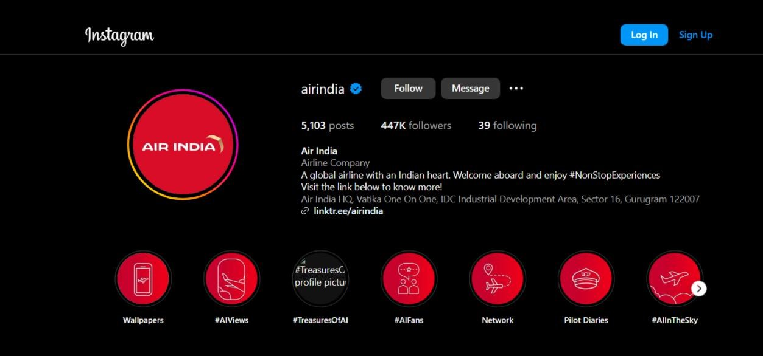

By selecting the Instagram icon, users are redirected to the platform’s official page. This serves as a familiar navigation feature, commonly integrated into website footers.